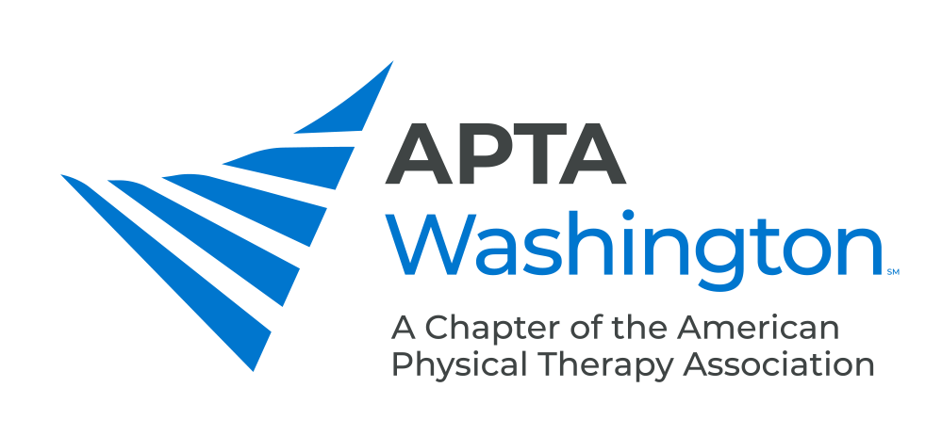

May 12, 2021

Debbie Roberts
Assistant Secretary
Developmental Disabilities Administration

Via email

Re: DSHS and Health Care Authority proposed amendments to the IFS, Basic Plus, Core, Community Protection, and CIIBS waivers

Dear Assistant Secretary Roberts:

On behalf of the APTA Washington, the Washington Speech-Language-Hearing Association (WSLHA), and the Washington Occupational Therapy Association (WOTA) and our combined 4000 members, we are writing to comment on the Department of Social & Health Services (DSHS) and Health Care Authority (HCA) proposed amendments to the IFS, Basic Plus, Core, Community Protection, and CIIBS waivers. Our associations are opposed to the amendment that removes physical therapy, occupational therapy, and speech, hearing and language services from these waivers. This amendment will have a harmful impact to those waiver participants who need these services.

The waiver summary states that all participants currently receiving physical therapy, occupational therapy, and speech therapy services will be transitioned to appropriate Medicaid State Plan services during their plan year 2021-2022. It further states that “the proposed changes will have no negative impacts to participants on the Basic Plus, Core and CIIBS waivers. We disagree. Waiver participants will lose access to important services they have received for years under the waivers, which will have a negative impact on their health and well-being.

DSHS and HCA assume that participants will be able to access appriopriate physical therapy, occupational therapy, and speech therapy through the Medicaid program. However, it is important to note that the physical therapy, occupational therapy, and speech therapy services that waiver participants receive is a community-based model, not a clinic-based model. Many of our patients who are on a waiver are not well-served in a clinic setting. Our patients receive services that are specially designed instruction in their natural environment in their home and community.

Many Medicaid providers are not able to provide the types of services needed by participants on waivers. Medicaid providers who are either pediatric-based or work with hospice or stroke patients or people in skilled nursing facilities. They typically work with their patients for brief times per week or month and reach contract limits early. Our patients are adults who are living in their community, not in an institutional setting. Our patients and their families report that it is extremely difficult to find appropriate services in the Medicaid model.

In addition, with this proposed change, our patients will lose important services that are not offered under Medicaid. For example, “Staff and Family Consultation” services are currently available under the waivers. However, this is a specialty consultation that is not reimbursed under Medicaid and will not be offered by Medicaid providers.

It is also important to understand that services offered under the waivers are appropriate and not duplicative to those offered under Medicaid. In fact, it is comparable to the differences between physical therapy, occupational therapy, and speech therapy delivered in schools and those same services offered under a clinically-based Medicaid model. We know that school-based services address educational impacts and provide specially designed instruction in the least restrictive environment. The therapies offered under the waivers are addressing home and community-based impacts in a natural environment. This is much different than services in the clinically-based Medicaid model.

It’s incredibly frustrating to know that our patients who are currently thriving under waiver-based physical therapy, occupational therapy, and speech therapy will lose access to these important therapies under the proposed waiver amendment. Please reconsider your proposal to remove these vital therapies from the IFS, Basic Plus, Core, Community Protection, and CIIBS waivers.

Sincerely,
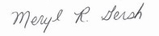
Meryl Gersh, PT, PhD
President, APTA Washington
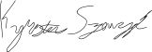
Kyrstin Szewczyk, OT
President, WOTA
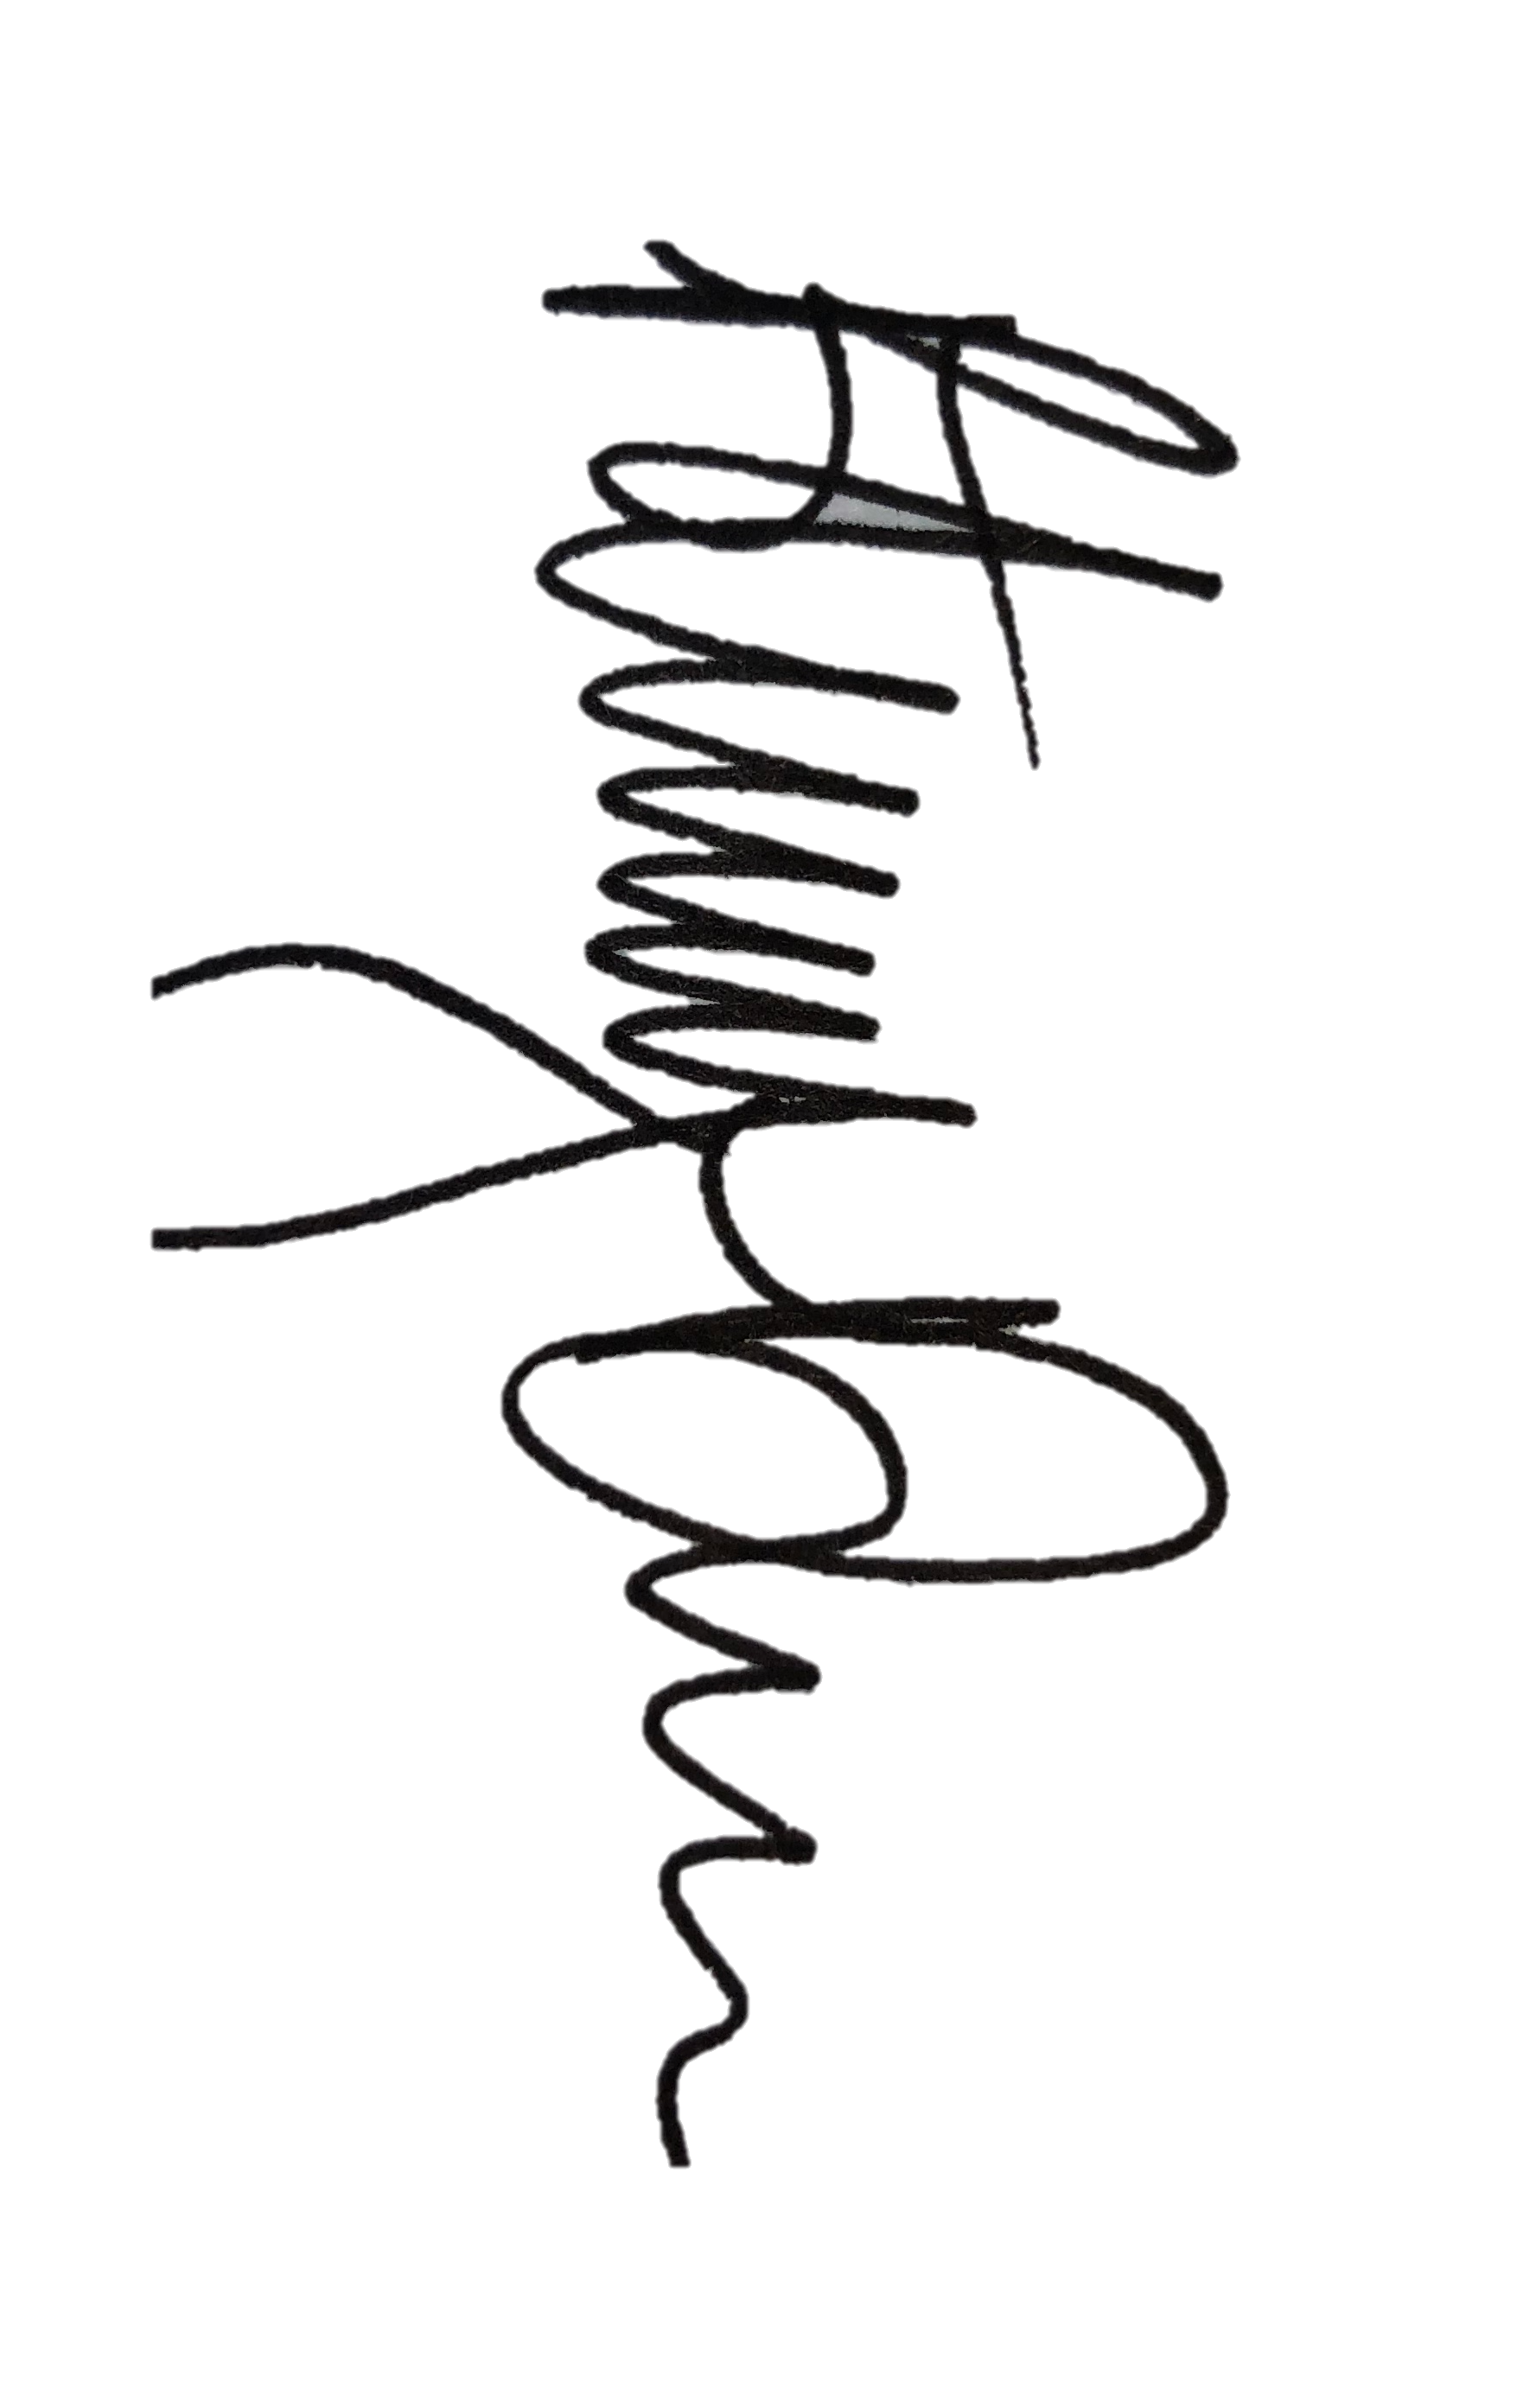
Bethany Davis, SLPD, CCC-SLP, CBIS
President, WSLHA

